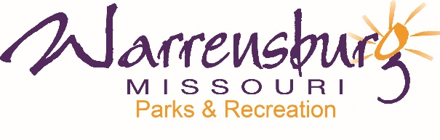

NEWS RELEASE FOR IMMEDIATE RELEASE

Contact: Jeff Imboden, B&I Specialist
Warrensburg Parks & Recreation (WPR)
445 E. Gay Street
(660) 747-7178

Warrensburg Shares Park and Recreation Story
Month-long celebration highlights the impact parks and recreation has on
communities across the country

WARRENSBURG, MO (June 29, 2021) – Warrensburg Parks & Recreation is celebrating Park and Recreation Month in July, an initiative of the National Recreation and Park Association (NRPA), with a month full of activities, events, and shared stories.
The City of Warrensburg kicked off Park & Recreation Month with Mayor Scott Holmberg reading a proclamation at the City Council meeting on June 28 recognizing that Parks and Recreation is important to maintaining the quality of life in the community, contributing to the economic and environmental well-being of a community, and declaring July 2021 as Parks & Recreation Month in the City of Warrensburg.
Warrensburg Parks & Rec (WPR) will celebrate and share their story starting with the family-friendly Freedom Fest 5K Run/Walk on July 3, as well as with Customer Appreciation Days at the Fitness Center, with informational “Did You Knows”, a coloring contest and artwork in the Community Center lobby, “Meet the WPR Staff” on social media, the Super Mario Kart E-Sport Tournament on July 22, a Dive-In Movie at Nassif on July 23, and more!
You are invited to be a part of the Warrensburg Parks & Rec story by visiting the local parks and sharing photos on WPR’s social media pages with your location, #OurParkAndRecStory, and by stopping by the Community Center to share your story on the Parks & Rec Story Wall in the front lobby. Make sure to download WPR’s Bucket List of fun things to do from their website, Warrensburg-mo.com. To learn more about Park and Recreation Month, visit www.nrpa.org/July.

About Warrensburg Parks & Recreation
The Warrensburg Parks & Recreation (WPR) Department is in its 51st year of managing the City of Warrensburg’s Parks & Recreation operations. The Department is responsible for maintaining 9 parks covering over 400 acres, including 3 award-winning parks – Cave Hollow, Grover Memorial and Shepard Park, miles of hiking trails, a skate park, dog park, 8 tennis courts, 6 playgrounds, 7 ballfields, 2 soccer fields, Nassif Aquatic Center (NAC) and the Warrensburg Community Center (WCC) which features a full size gymnasium with 6 basketball goals, a Walking Track, the Indoor Pool Facility, 7 meeting rooms, and the award-winning WCC Fitness Center. WPR prides itself in providing diverse, accessible, and multi-faceted Sports, Aquatics, Fitness & Exercise Programs, as well many special events and activities. WPR provides equal access to everyone while connecting and engaging children, families, and communities.

About the National Recreation and Park Association
The National Recreation and Park Association (NRPA) is the leading not-for-profit organization dedicated to building strong, vibrant and resilient communities through the power of parks and recreation. With more than 60,000 members, NRPA advances this mission by investing in and championing the work of park and recreation professionals and advocates — the catalysts for positive change in service of equity, climate-readiness, and overall health and well-being. For more information, visit www.nrpa.org. For digital access to NRPA’s flagship publication, Parks & Recreation, visit www.parksandrecreation.org.
# # #
Pictures Attached
