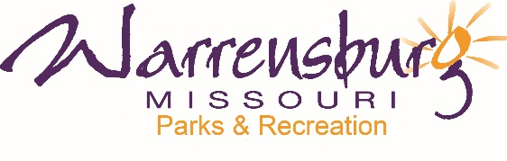

NEWS RELEASE FOR IMMEDIATE RELEASE

Contact: Jeff Imboden, B&I Specialist
Warrensburg Parks & Recreation (WPR)
445 E. Gay Street
(660) 747-7178

Nassif Aquatic Center Summer 2020 Statement

WARRENSBURG, MO (June 10, 2020) – Warrensburg Parks & Recreation (WPR) has released a statement concerning the decision not to open Nassif Aquatic Center (NAC) for the 2020 summer season.

“We never thought we would be faced with a decision whether or not to open the pool for the summer,” said WPR Director Danielle Fesler. “We know how important Nassif is to our community, and although we discussed all options to open Nassif, it was just not feasible to do so, due to social distancing and sanitation protocol, while still offering equal access to everyone. It was a very difficult decision.”

The Nassif Aquatic Center Summer 2020 Statement is available online at www.warrensburg-mo.com/160/Parks-Recreation. The full WCC Phase 1 Reopening Plan, which includes a limited opening of the Indoor Pool at the Community Center, is available online as well.

Follow WPR on social media for the most up-to-date information. COVID-19 updates can be found online at www.warrensburg-mo.com and at www.johnsoncountyhealth.org/news/covid-19-information

Attached: Nassif Aquatic Center Summer 2020 Statement

